Curriculum Vitae

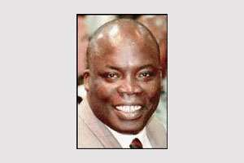

Abdoul Aziz M'BAYE (Dr.)

Mr. Abdoul Aziz M'Baye is a French National. He was born on 18th October 1954 in Dakar (Sénégal).

Mr. M'Baye studied Physics at the University of Paris and obtained a PhD in 1984. He also holds diploma/Masters in Economics, International Relations and Public Management obtained from different Universities in Belgium from 1989 to 1993. Mr. M'Baye worked as a permanent researcher of the French National Centre for Research (CNRS).

Abdoul Aziz M'Baye started his career with the European Commission / Brussels in 1988 in the European Strategic Programme for Research & Development in the field of Information Technologies (ESPRIT). He then joined the Directorate General for Industry where he dealt with competitiveness and general questions on industrial and technological policies

In 1996, Abdoul Aziz M'Baye joined the EC Delegation in South Africa as Political, Economic and Trade Counsellor. This was followed by period in the EC Delegation to the Republic of Guinea (Conakry) before returning in 2004 to Headquarters at the Directorate for the External Service dealing with delegations management.

In 2007, Mr M'Baye joined the EC Delegation in the Solomon Islands as the chargé d'Affaires a.i.

In 2011, Mr M'Baye was appointed as Ambassador/Head of the EU Delegation for the Pacific, which is responsible for 15 Pacific countries and territories (Cook Islands, Federated States of Micronesia, Fiji, French Polynesia, Kiribati, Nauru, New Caledonia, Niue, Marshall Islands, Palau, Pitcairn, Samoa, Tonga, Tuvalu, Wallis and Futuna).

Fiji, January 2012

